GSA Blog Post for Women Veterans Supplement

Dear GSA Colleagues,

As a women’s health epidemiologist, my goal is to identify and intervene on risk factors that put aging women at risk of poor health outcomes or reduced quality of life…and on the positive side aging, to identify factors that help us age well and improve our quality of life. Military service is an understudied life course factor in both men and women, but especially women. Today, it’s estimated that about 1.5 million women veterans are living in the US and Puerto Rico. As shown in the graph below, World War II still remains the era when the most women were serving, but numbers of women serving in the military are now high again. The median age of US women veterans was about 48 in 2009, but just like the rest of us, these 1.5 million women are aging, and their past military service could contribute to their likelihood of aging well, or developing health problems.
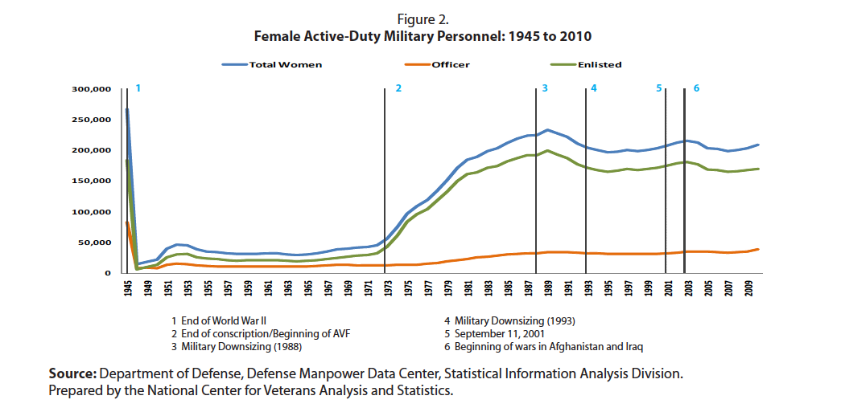

Reference: National Center for Veterans Analysis and Statistics. America’s Women Veterans: Military Service History and VA Benefit Utilization Statistics. National Center for Veterans Analysis and Statistics, Department of Veterans Affairs, Washington, DC. November 2011.

We have just published a special supplement to the February 2016 issue of The Gerontologist. Both the main journal issue (http://bit.ly/VeteranWomen) and our supplement (http://bit.ly/AgingVeterans) are devoted to studies of aging women veterans. Our supplement (Co-editors Gayle Reiber, PhD and Andrea LaCroix PhD) focuses on nearly 4000 women who joined the Women’s Health Initiative (WHI) in 1993-1998, some of whom have been part of this study for more than two decades. Most of the veterans in WHI served in World War II or the Korea/Vietnam war era. The average age of WHI women who survived is just over 80 years now. These women are teaching us much about how prior military service is associated with various indicators of healthy aging, menopause and gynecologic procedures, chronic diseases including fracture, diabetes and lung cancer incidence, and risk of dying compared to their non-Veteran peers in WHI. The supplement was supported by the VA and a true collaboration between VA and WHI scientists. Moreover, we sent the surviving WHI veterans a newsletter about these findings, and we’ve begun to dialogue with the women themselves about their experiences and their thoughts on what might explain the differences in aging and health status between older women with and without prior military service.

We invite you to read this special supplement, and to send us any comments or questions you have about this work. Many of the issues we’ve identified are amenable to prevention or could be improved through innovative health services programs. The numbers of women veterans are growing, as is their exposure to hazardous conditions in the military theatre including combat. We owe it to all of those who have served to understand how to preserve and protect their health and wellness as they grow older.

With kindest regards,
Andrea Z. LaCroix, PhD
Professor and Chief of Epidemiology
Director, Women’s Health Center of Excellence
Department of Family Medicine and Public Health
University of California, San Diego

